*Form 1/18*

Results template for Task 1

Support for IFC within BIM (and other) software

# **Section 1 - Participant** **information**

# This information has already been captured in the "Registration of interest in participation" form; here we only ask you your name and e-mail, to connect the two parts for our final analysis.

# In the case something has changed, please communicate it through e-mail at f.noardo@tudelft.nl

|  |  |
| --- | --- |
| Your Name and Surname | Helen Eriksson |
| Your e-mail address | Helen.eriksson@nateko.lu.se |

# **Section 2 - Tested Software/tool**

|  |  |
| --- | --- |
| Software Name | BIM Visison 2.20.3 |
| Software house / vendor / developer | Datacomp Sp. z o.o. |
| Proprietary / open source | ☐ proprietary  ☐ open source software |
| Version |  |
| Kind of software (CAD/BIM/GIS/3DViewer/other) | ☐BIM  ☐ GIS  ☐ 3D Viewer  ☐ CAD  ☐ 3D Analyser  ☐ Facility Management software  ☐ Extract/Transformation Load  ☐ Other (specify):_____________ |
| What kind of IFC management is possible?  (multiple answers allowed) | ☐ import  ☐ export  ☐ view  ☐ query  ☐ analysis  ☐ other___________ |
| IFC certification status of the software for import? | ☐ not certified  ☐ certification in progress → certification program: __________  ☐ certified in: (insert date) → certification program: _________ |
| IFC certification status of the software for export | ☐ not certified  ☐ certification in progress → certification program: __________  ☐ certified in: (insert date) → certification program: _________ |

# **Section 3 - Computer hardware used**

|  |  |
| --- | --- |
| Model and year | HP ZBook 15 G3, 2018 |
| Operating system and version | Windows 10 Enterprise, 64-bit |
| CPU | Intel ® Core™ i7-6820HQ CPU |
| GPU | NVIDIA Quatro M1000M |
| Memory (RAM) | 32 GB |
| Hard drive capacity | 474 GB |
| Hard drive free space | 217 GB |

*Form 2/18*

**Section 4/1 - The Task**

**Test with Myran.ifc**

 Please, remember to **turn off all the unnecessary processes**, software and tools in the computer during the test, and check the approximated required processing time.

We advise you to have a look at the whole task (described in this results template and in the corresponding one in word format) before beginning to answer. In this way you will be aware of what is asked and will not miss anything, nor lose time in going back and forward.

**Phase 1 - IMPORT FUNCTIONALITY.**

Import *Myran.ifc* into the software and answer the following questions.

1) Initial performance time evaluation.

How long does it take, approximately, to (notice that in the web form, the questions are more detailed, including images for reference):

|  |  |
| --- | --- |
| Import and visualise the model | ☐ it’s almost immediate  ☐ less than a minute  ☐ 1-5 minutes  ☐ 5-20 minutes  ☐ 20 minutes - 1 hour  ☐ more than 1 hour  ☐ it crashes without completing the operation  ☐ the software does not allow this |
| Zoom the model to see more detail | ☐ it’s almost immediate  ☐ less than a minute  ☐ 1-5 minutes  ☐ 5-20 minutes  ☐ 20 minutes - 1 hour  ☐ more than 1 hour  ☐ it crashes without completing the operation  ☐ the software does not allow this |
| Pan the model | ☐ it’s almost immediate  ☐ less than a minute  ☐ 1-5 minutes  ☐ 5-20 minutes  ☐ 20 minutes - 1 hour  ☐ more than 1 hour  ☐ it crashes without completing the operation  ☐ the software does not allow this |
| Rotate the model | ☐ it’s almost immediate  ☐ less than a minute  ☐ 1-5 minutes  ☐ 5-20 minutes  ☐ 20 minutes - 1 hour  ☐ more than 1 hour  ☐ it crashes without completing the operation  ☐ the software does not allow this |
| Query an object | ☐ it’s almost immediate  ☐ less than a minute  ☐ 1-5 minutes  ☐ 5-20 minutes  ☐ 20 minutes - 1 hour  ☐ more than 1 hour  ☐ it crashes without completing the operation  ☐ the software does not allow this |
| Inspect the objects linked to the queried one through a relationship | ☐ it’s almost immediate  ☐ less than a minute  ☐ 1-5 minutes  ☐ 5-20 minutes  ☐ 20 minutes - 1 hour  ☐ more than 1 hour  ☐ it crashes without completing the operation  ☐ the software does not allow this |

*Form 3/18*

Task 1 - 3/18

Following the test with the Myran.ifc model

**Georeferencing**

When you import the model into the software, does it lose its georeferencing information?

2) Details about the coordinate reference system of the imported model

2.1) Are the world (projected) coordinates taken into account for locating the model in the software’s coordinate reference system? (and it is not automatically moved closer to the origin when imported).

|  |  |
| --- | --- |
| ☐ Yes | |
| ☐ No → | 2.1.1) Where is the origin of the model coordinate reference system as imported in the software?  Give a description  2.1.2) Attach screenshots[1]  2.1.3) What is the coordinate reference system and projection and what unit of measure is used for the representation?  Give a description  2.1.4) Attach screenshots |
| ☐ The software does not have the necessary tools to check this information. | |

2.2) short comments to the previous question (2.1) (optional).

3) Details about the height reference system of the imported model

3.1) Are the “real-world” elevation values (heights) considered when locating the model in the software (z)?

(i.e. it is not automatically moved to height 0 when imported)

|  |  |
| --- | --- |
| ☐ Yes | |
| ☐ No → | 3.1.1) What is the elevation value of the origin of the model coordinate reference system as imported in the software?  Give a description  3.1.2) Attach screenshots  3.1.3) What is the height reference system?  Give a description  3.1.4) Attach screenshots |
| ☐ The software does not have the necessary tools to check this information. | |

3.2) short comments to the previous question (3.1) (optional).

4) Details about the imported model orientation

4.1) Is the model oriented correctly with respect to the true North?

(i.e. it is not automatically rotated to align with the system axes when imported)

|  |  |
| --- | --- |
| ☐ Yes | |
| ☐No → | 4.1.1) How is the model oriented, with respect to the reference direction?  Give a description  4.1.2) Attach screenshots |
| ☐ The software does not have the necessary tools to check this information. | |

4.2) short comments to the previous question (4.1) (optional).

5) Details about the imported model dimensions and proportions

5.1) Does the model maintain its correct dimensions and proportions?

(i.e. it is not distorted nor scaled)

|  |  |
| --- | --- |
| ☐ Yes | |
| ☐ No → | 5.1.1) How do the dimensions change / how is the model distorted?  Give a description  5.1.2) Attach screenshots |
| ☐ The software does not have the necessary tools to check this information. | |

5.2) short comments to the previous question (5.1) (optional).

*Defined distance:22840 Measured distance: 22622*

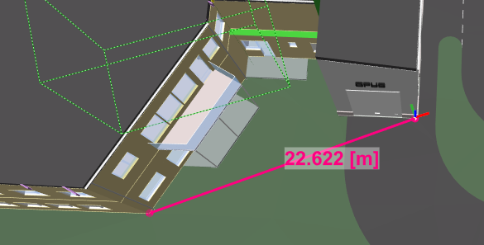

*Form 4/18*

Task 1 - 4/18

Following the test with the Myran.ifc model

**Semantics**

How are the semantics translated into the software's internal library / vocabulary?

6) Details about the classification

Is the IFC classification retained?

6.1) Is the eventual translation consistent with the IFC definitions?

(are the walls still walls, are the doors still doors and so on)

|  |  |
| --- | --- |
| ☐ Yes | |
| ☐ No → | 6.1.1) What changes / inconsistencies / errors / other issues were noted?  Give a description  6.1.2) Attach screenshots |
| ☐ The software does not have the necessary tools to check this information. | |

6.2) short comments to the previous question (6.1) (optional).

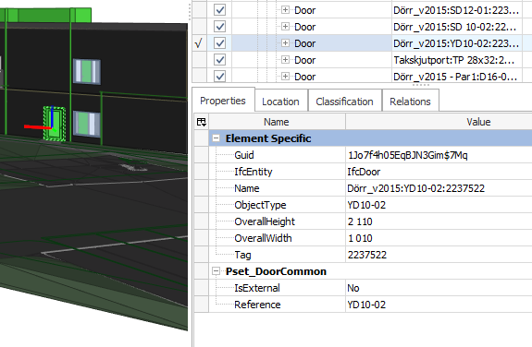

7) Details about the hierarchy

7.1) Are the hierarchical relationships consistent with the IFC hierarchy?

(are the class-subclass relationships maintained)

|  |  |
| --- | --- |
| ☐ Yes | |
| ☐ No → | 7.1.1) What changes / inconsistencies / errors / other issues were noted?  Give a description  7.1.2) Attach screenshots |
| ☐ The software does not have the necessary tools to check this information. | |

7.2) short comments to the previous question (7.1) (optional).

*Example of hierarchy:*

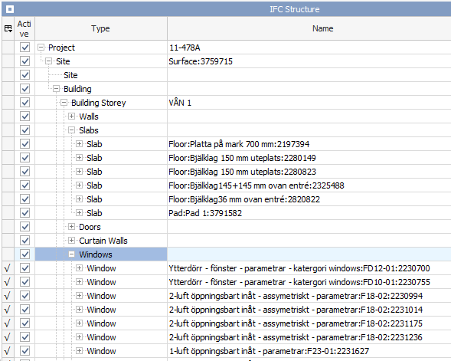

8) Details about the attributes

8.1) Are the attributes present in the IFC entities retained and consistent?

(can they all be read in connection to the related entities and have the correct meaning)

|  |  |
| --- | --- |
| ☐ Yes | |
| ☐ No → | 8.1.1) What changes / inconsistencies / errors / other issues were noted?  Give a description  8.1.2) Attach screenshots |
| ☐ The software does not have the necessary tools to check this information. | |

8.2) short comments to the previous question (8.1) (optional).

*Some examples of attributes:*

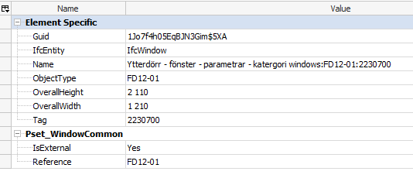

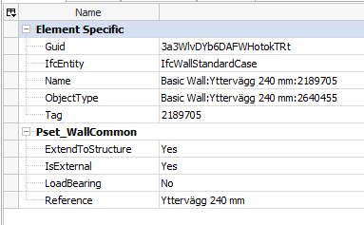

9) Details about the relationships

9.1) Are the relationships between the objects retained?

(intended as different from hierarchical relationships)

|  |  |
| --- | --- |
| ☐ Yes | |
| ☐ No → | 9.1.1) What changes / inconsistencies / errors / other issues were noted?  Give a description  9.1.2) Attach screenshots |
| ☐ The software does not have the necessary tools to check this information. | |

9.2) short comments to the previous question (9.1) (optional).

*Some relations might be missing*

*Form 5/18*

Task 1 - 5/18

Following the test with the Myran.ifc model

**Geometry**

How are the geometries managed?

10) Details about the kind of geometries

10.1) Is geometry read correctly?

(solids are solids, surfaces are surfaces, objects are not grouped nor broken)

|  |  |
| --- | --- |
| ☐ Yes | |
| ☐ No → | 10.1.1) What changes / inconsistencies / errors / other issues were noted?  Give a description  10.1.2) Attach screenshots |
| ☐ The software does not have the necessary tools to check this information. | |

10.2) short comments to the previous question (3.1.1) (optional).

11) Details about the normals

11.1) Are normals not changed?

possibly, you can at least visually check this, through the way the objects are visualised (e.g. different colours for different faces directions)

|  |  |
| --- | --- |
| ☐ Yes | |
| ☐ No → | 11.1.1) What changes / inconsistencies / errors / other issues were noted?  Give a description  11.1.2) Attach screenshots |
| ☐ The software does not have the necessary tools to check this information. | |

11.2) short comments to the previous question (11.1) (optional).

*Visually, I think it is correct:*

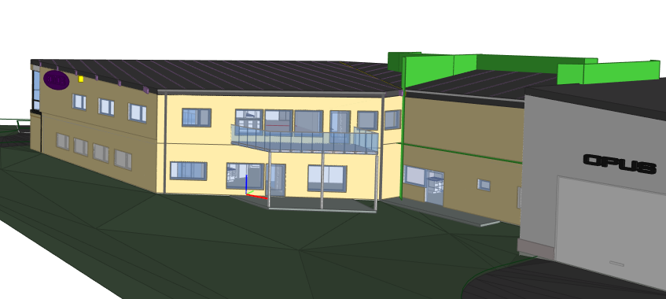

**Model management**

12) Visualisation 3D

12.1) Is it possible to view the model in 3D?

☐ Yes

☐ No

12.2) short comments to the previous question (12.1) (optional).

13) Visualisation 2D

13.1) Is it possible to view the model in 2D?

☐ Yes

☐ No

13.2) short comments to the previous question (13.1) (optional).

14) Editing possibilities

14.1) Is it possible to edit the model (attributes, geometry, other)?

|  |  |
| --- | --- |
| ☐ No | |
| ☐ Yes→ | 14.1.1) What editing is possible (attributes, geometry, georeferencing, please add details)?  Give a description  14.1.2) Attach screenshots  14.1.3) Needed time to perform the edits  (approximately)  ⚠ NB: do not save the edits, as you will need to re-export the original data later on!  ☐ it’s almost immediate  ☐ less than a minute  ☐ 1-5 minutes  ☐ 5-20 minutes  ☐ 20 minutes - 1 hour  ☐ more than 1 hour  ☐ it crashes without completing the operation |

14.2) short comments to the previous question (14.1) (optional).

*I cannot find such possibilities.*

15) Query possibilities

15.1) Is it possible to query the model and the attributes?

|  |
| --- |
| ☐ No |

|  |  |
| --- | --- |
| ☐ Yes→ | 15.1.1) What kinds of query are possible?  Give a description  *There are general pre-defined ways to view the information, listed by structure, by types, by groups (system, zones or other) and by layers. For all these properties, location, classification and relations can be shown at the object level.*  15.1.2) Attach screenshots  *List by types*:    *List by other groups:*    *List by layers:* |

15.2) short comments to the previous question (15.1) (optional).

16) Analysis possibilities

16.1) Is it possible to analyse the objects and the model?

|  |  |
| --- | --- |
| ☐ No | |
| ☐ Yes→ | 16.1.1) What analysis are possible? Do you know if the results are reliable?  Give a description  *Volume, area, edge, weight steel, counting and coordinates can be measured.  Do not know it they are reliable*  16.1.2) Attach screenshots  *Volume:*    *Area:*    *Edge:*    *Steel weight:*    *Coordinates:*    16.1.3) Needed time to perform the analysis  (approximately)  ☐ it’s almost immediate  ☐ less than a minute  ☐ 1-5 minutes  ☐ 5-20 minutes  ☐ 20 minutes - 1 hour  ☐ more than 1 hour  ☐ it crashes without completing the operation |

16.2) short comments to the previous question (16.1) (optional).

*Form 6/18*

Task 1 - 6/12

Following the test with the Myran.ifc model

**You arrived at the end of the Phase 1: “Import and manage the file in the software”**

Now choose:

☐ The software has also export abilities

☐ The software cannot export, therefore **skip the phase 2**

**Phase 2: EXPORT the data again to IFC and answer the following questions.**

(Only complete this section software tools having export functionality)

You should export the data to the **same IFC version of the provided data;** optionally, file(s) exported to **different IFC version(s)** can also be provided in addition, if multiple versions are offered by the software, and it is (/they are) **welcome.**

17) Details about the needed customisation

17.1) Are any pre-processing or setting changes needed in the software to enable a consistent export?

|  |  |
| --- | --- |
| ☐ No | |
| ☐ Yes→ | 17.1.1) Can you add a short description of the steps involved in the pre-processing?  Give a description  17.1.2) Attach screenshots[2] |

17.2) short comments to the previous question (17.1) (optional).

18) Details about the possibility to use Model View Definitions (MVD)

18.1) Is it possible to choose the IFC model view definition (MVD) to be used when exporting the data?

|  |  |  |
| --- | --- | --- |
| ☐ No |  | |
| ☐ Yes → | 18.1.1) Which ones are available?  Give a description | |
|  | 18.1.2) Is it possible to add a customised MVD to be used for exporting IFC? | |
|  | ☐ No | |
|  | ☐ Yes → | 18.1.2.1) What kind of customization is possible?  Give a description  18.1.2.2) Attach screenshots |
| ☐ The software does not have the necessary tools to check this information. | | |

18.2) short comments to the previous question (6.1) (optional).

19) How long does it take for the data to be exported to IFC?

(approximately)

☐ it’s almost immediate

☐ less than a minute

☐ 1-5 minutes

☐ 5-20 minutes

☐ 20 minutes - 1 hour

☐ more than 1 hour

☐ it crashes without completing the operation

*Form 7/18*

Task 1 - 7/12

Following section 4 – the Task

Test with the second model: UpTown.ifc

**Phase 1 – IMPORT FUNCTIONALITY.**

**Close and re-open the software again;**

**Import *UpTown.ifc* into the software and answer the following questions.**

20) Initial performance time evaluation.

How long does it take, approximately, to (more details in the web form):

|  |  |
| --- | --- |
| Import and visualise the model | ☐ it’s almost immediate  ☐ less than a minute  ☐ 1-5 minutes  ☐ 5-20 minutes *It took about 10 minutes*  ☐ 20 minutes - 1 hour  ☐ more than 1 hour  ☐ it crashes without completing the operation  ☐ the software does not allow this |
| Zoom the model to see more detail | ☐ it’s almost immediate  ☐ less than a minute  ☐ 1-5 minutes  ☐ 5-20 minutes  ☐ 20 minutes - 1 hour  ☐ more than 1 hour  ☐ it crashes without completing the operation  ☐ the software does not allow this |
| Pan the model | ☐ it’s almost immediate  ☐ less than a minute  ☐ 1-5 minutes  ☐ 5-20 minutes  ☐ 20 minutes - 1 hour  ☐ more than 1 hour  ☐ it crashes without completing the operation  ☐ the software does not allow this |
| Rotate the model | ☐ it’s almost immediate  ☐ less than a minute  ☐ 1-5 minutes  ☐ 5-20 minutes  ☐ 20 minutes - 1 hour  ☐ more than 1 hour  ☐ it crashes without completing the operation  ☐ the software does not allow this |
| Query an object | ☐ it’s almost immediate  ☐ less than a minute  ☐ 1-5 minutes  ☐ 5-20 minutes  ☐ 20 minutes - 1 hour  ☐ more than 1 hour  ☐ it crashes without completing the operation  ☐ the software does not allow this |
| Inspect the objects linked to the queried one through a relationship | ☐ it’s almost immediate  ☐ less than a minute  ☐ 1-5 minutes  ☐ 5-20 minutes  ☐ 20 minutes - 1 hour  ☐ more than 1 hour  ☐ it crashes without completing the operation  ☐ the software does not allow this |

*Form 8/18*

Task 1 - 8/12

Following the test with the UpTown.ifc model

**Georeferencing**

When you import the model into the software, does it lose its georeferencing information?

21) Details about the coordinate reference system of the imported model

21.1) Are the world (projected) coordinates taken into account for locating the model in the software’s coordinate reference system?

(and it is not automatically moved closer to the origin when imported)

|  |  |
| --- | --- |
| ☐ Yes | |
| ☐ No → | 21.1.1) Where is the origin of the model coordinate reference system as imported in the software?  Give a description  21.1.2) Attach screenshots  21.1.3) What is the coordinate reference system and projection and what unit of measure is used for the representation?  Give a description  21.1.4) Attach screenshots |
| ☐ The software does not have the necessary tools to check this information. | |

21.2) short comments to the previous question (21.1) (optional).

22) Details about the height reference system of the imported model

22.1) Are the “real-world” elevation values (heights) considered when locating the model in the software (z)?

(i.e. it is not automatically moved to height 0 when imported)

|  |  |
| --- | --- |
| ☐ Yes | |
| ☐ No → | 22.1.1) What is the elevation value of the origin of the model coordinate reference system as imported in the software?  Give a description  22.1.2) Attach screenshots  22.1.3) What is the height reference system?  Give a description  22.1.4) Attach screenshots |
| ☐ The software does not have the necessary tools to check this information. | |

22.2) short comments to the previous question (22.1) (optional).

23) Details about the imported model orientation

23.1) Is the model oriented correctly with respect to the true North?

(i.e. it is not automatically rotated to align with the system axes when imported)

|  |  |
| --- | --- |
| ☐ Yes | |
| ☐ No → | 23.1.1) How is the model oriented, with respect to the reference direction?  Give a description  23.1.2) Attach screenshots |
| ☐ The software does not have the necessary tools to check this information. | |

23.2) short comments to the previous question (23.1) (optional).

24) Details about the imported model dimensions and proportions

24.1) Does the model maintain its correct dimensions and proportions?

(i.e. it is not distorted nor scaled)

|  |  |
| --- | --- |
| ☐ Yes | |
| ☐ No → | 24.1.1) How do the dimensions change / how is the model distorted?  Give a description  24.1.2) Attach screenshots |
| ☐ The software does not have the necessary tools to check this information. | |

24.2) short comments to the previous question (24.1) (optional).

*Defined distance:22958 Measured distance: 22458*

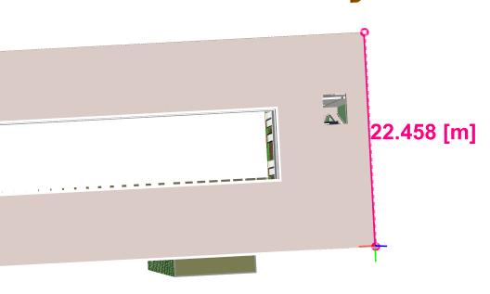

*Form 9/18*

Task 1 - 9/18

Following the test with the UpTown.ifc model

**Semantics**

How are the semantics translated into the software's internal library / vocabulary?

25) Details about the classification

Is the IFC classification retained?

25.1) Is the eventual translation consistent with the IFC definitions?

(are the walls still walls, are the doors still doors and so on)

|  |  |
| --- | --- |
| ☐ Yes | |
| ☐ No → | 25.1.1) What changes / inconsistencies / errors / other issues were noted?  Give a description  25.1.2) Attach screenshots |
| ☐ The software does not have the necessary tools to check this information. | |

25.2) short comments to the previous question (25.1) (optional).

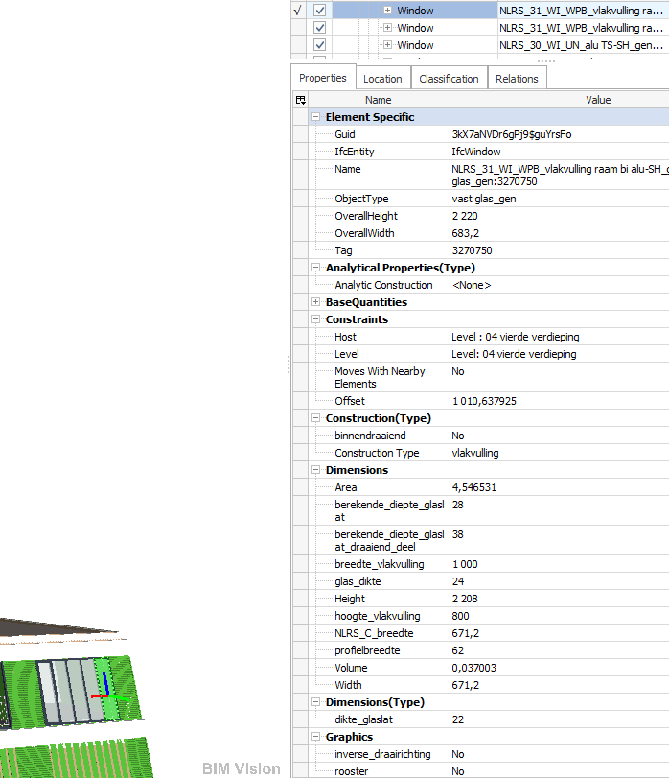

26) Details about the hierarchy

26.1) Are the hierarchical relationships consistent with the IFC hierarchy?

(are the class-subclass relationships maintained)

|  |  |
| --- | --- |
| ☐ Yes | |
| ☐ No → | 26.1.1) What changes / inconsistencies / errors / other issues were noted?  Give a description  26.1.2) Attach screenshots |
| ☐ The software does not have the necessary tools to check this information. | |

26.2) short comments to the previous question (26.1) (optional).

*Example of hierarchy:*

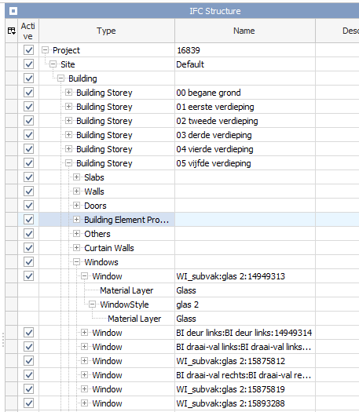

27) Details about the attributes

27.1) Are the attributes present in the IFC entities retained and consistent?

(can they all be read in connection to the related entities and have the correct meaning)

|  |  |
| --- | --- |
| ☐ Yes | |
| ☐ No → | 27.1.1) What changes / inconsistencies / errors / other issues were noted?  Give a description  27.1.2) Attach screenshots |
| ☐ The software does not have the necessary tools to check this information. | |

27.2) short comments to the previous question (27.1) (optional).

*Example of attributes:*

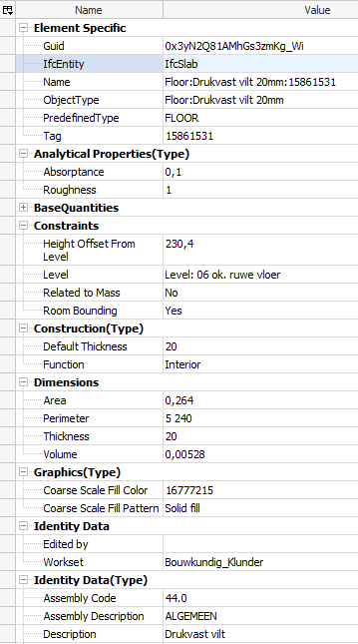

28) Details about the relationships

28.1) Are the relationships between the objects retained?

(intended as different from hierarchical relationships)

|  |  |
| --- | --- |
| ☐ Yes | |
| ☐ No → | 28.1.1) What changes / inconsistencies / errors / other issues were noted?  Give a description  28.1.2) Attach screenshots |
| ☐ The software does not have the necessary tools to check this information. | |

28.2) short comments to the previous question (28.1) (optional).

*Form 10/18*

Task 1 - 10/18

Following the test with the UpTown.ifc model

**Geometry**

How are the geometries managed?

29) Details about the kind of geometries

29.1) Is geometry read correctly?

(solids are solids, surfaces are surfaces, objects are not grouped nor broken)

|  |  |
| --- | --- |
| ☐ Yes | |
| ☐ No → | 29.1.1) What changes / inconsistencies / errors / other issues were noted?  Give a description  29.1.2) Attach screenshots |
| ☐ The software does not have the necessary tools to check this information. | |

29.2) short comments to the previous question (29.1) (optional).

30) Details about the normals

30.1) Are normals not changed?

possibly, you can at least visually check this, through the way the objects are visualised (e.g. different colours for different faces directions)

|  |  |
| --- | --- |
| ☐ Yes | |
| ☐ No → | 30.1.1) What changes / inconsistencies / errors / other issues were noted?  Give a description  30.1.2) Attach screenshots |
| ☐ The software does not have the necessary tools to check this information. | |

30.2) short comments to the previous question (30.1) (optional).

*Visually, I think it is correct:*

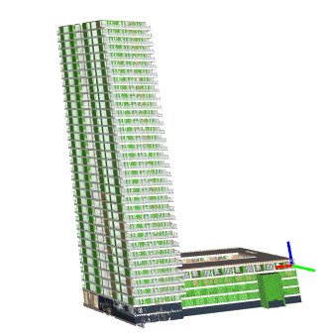

**Model management**

31) Visualisation 3D

31.1) Is it possible to view the model in 3D?

☐ Yes

☐ No

31.2) short comments to the previous question (31.1) (optional).

32) Visualisation 2D

32.1) Is it possible to view the model in 2D?

☐Yes

☐ No

32.2) short comments to the previous question (32.1) (optional).

33) Editing possibilities

33.1) Is it possible to edit the model (attributes, geometry, other)?

|  |  |
| --- | --- |
| ☐ No | |
| ☐ Yes→ | 33.1.1) What editing is possible (attributes, geometry, georeferencing, please add details)?  Give a description  33.1.2) Attach screenshots  33.1.3) Needed time to perform the edits  (approximately)  ⚠ NB: do not save the edits as you will need to re-export the original data later on!  ☐ it’s almost immediate  ☐ less than a minute  ☐ 1-5 minutes  ☐ 5-20 minutes  ☐ 20 minutes - 1 hour  ☐ more than 1 hour  ☐ it crashes without completing the operation |

33.2) short comments to the previous question (33.1) (optional).

34) Query possibilities

34.1) Is it possible to query the model and the attributes?

|  |  |
| --- | --- |
| ☐ No | |
| ☐ Yes→ | 34.1.1) What kinds of query are possible?  Give a description  *There are general pre-defined ways to view the information, listed by structure, by types, by groups (system, zones or other) and by layers. For all these properties, location, classification and relations can be shown on the object level, see question 15.1.*  34.1.2) Attach screenshots  *List by classification:* |

34.2) short comments to the previous question (34.1) (optional).

35) Analysis possibilities

35.1) Is it possible to analyse the objects and the model?

|  |  |
| --- | --- |
| ☐ No | |
| ☐ Yes→ | 35.1.1) What analysis are possible? Do you know if the results are reliable?  Give a description  *Volume, area, edge, weight steel, counting and coordinates can be measured.*  *Do not know if it is reliable.*  35.1.2) Attach screenshots  *Volume:*    *Area:*    *Edge:*    *Concrete weight:*    *Coordinates:*    35.1.3) Needed time to perform the analysis  (approximately)  ☐ it’s almost immediate  ☐ less than a minute  ☐ 1-5 minutes  ☐ 5-20 minutes  ☐ 20 minutes - 1 hour  ☐ more than 1 hour  ☐ it crashes without completing the operation |

35.2) short comments to the previous question (35.1) (optional).

*Form 11/18*

Task 1 - 11/18

Following the test with the UpTown.ifc model

**You arrived at the end of the Phase 1: “Import and manage the file in the software”**

Now choose:

☐ The software has also export abilities

☐ The software cannot export, therefore **skip the phase 2**

**Phase 2: EXPORT the data again to IFC and answer the following questions.**

(Only complete this section software tools having export functionality)

You should export the data to the **same IFC version of the provided data;** optionally, file(s) exported to **different IFC version(s)** can also be provided in addition, if multiple versions are offered by the software, and it is (/they are) **welcome.**

The needed customization is supposed to be the same reported for the test with Myran.ifc; otherwise, you can describe more details in the following comment section.

36) How long does it take for the data to be exported to IFC?

(approximately)

☐ it’s almost immediate

☐ less than a minute

☐ 1-5 minutes

☐ 5-20 minutes

☐ 20 minutes - 1 hour

☐ more than 1 hour

☐ it crashes without completing the operation

36.1) Comment to the previous question (optional)

36.2) Attach screenshots (optional)

*Form 12/18*

**Following Section 4 - The Task**

**Test with Savigliano.ifc**

 Please, remember to **turn off all the unnecessary processes**, software and tools in the computer during the test, and check the approximated required processing time.

We advise you to have a look at the whole task (described in this results template and in the corresponding one in word format) before beginning to answer. In this way you will be aware of what is asked and will not miss anything, nor lose time in going back and forward.

**Phase 1 - IMPORT FUNCTIONALITY.**

Import *Savigliano.ifc* into the software and answer the following questions.

37) Initial performance time evaluation.

How long does it take, approximately, to (notice that in the web form, the questions are more detailed, including images for reference):

|  |  |
| --- | --- |
| Import and visualise the model | ☐ it’s almost immediate  ☐ less than a minute  ☐ 1-5 minutes  ☐ 5-20 minutes  ☐ 20 minutes - 1 hour  ☐ more than 1 hour  ☐ it crashes without completing the operation  ☐ the software does not allow this |
| Zoom the model to see more detail | ☐ it’s almost immediate  ☐ less than a minute  ☐ 1-5 minutes  ☐ 5-20 minutes  ☐ 20 minutes - 1 hour  ☐ more than 1 hour  ☐ it crashes without completing the operation  ☐ the software does not allow this |
| Pan the model | ☐ it’s almost immediate  ☐ less than a minute  ☐ 1-5 minutes  ☐ 5-20 minutes  ☐ 20 minutes - 1 hour  ☐ more than 1 hour  ☐ it crashes without completing the operation  ☐ the software does not allow this |
| Rotate the model | ☐ it’s almost immediate  ☐ less than a minute  ☐ 1-5 minutes  ☐ 5-20 minutes  ☐ 20 minutes - 1 hour  ☐ more than 1 hour  ☐ it crashes without completing the operation  ☐ the software does not allow this |
| Query an object | ☐ it’s almost immediate  ☐ less than a minute  ☐ 1-5 minutes  ☐ 5-20 minutes  ☐ 20 minutes - 1 hour  ☐ more than 1 hour  ☐ it crashes without completing the operation  ☐ the software does not allow this |
| Inspect the objects linked to the queried one through a relationship | ☐ it’s almost immediate  ☐ less than a minute  ☐ 1-5 minutes  ☐ 5-20 minutes  ☐ 20 minutes - 1 hour  ☐ more than 1 hour  ☐ it crashes without completing the operation  ☐ the software does not allow this |

38) Please report on any errors the software give when importing the file

39) Attach screenshots regarding the eventually reported errors

*Form 13/18*

Task 1 - 13/18

Following the test with the Savigliano.ifc model

**Georeferencing**

When you import the model into the software, does it lose its georeferencing information?

40) Details about the coordinate reference system of the imported model

40.1) Are the world (projected) coordinates taken into account for locating the model in the software’s coordinate reference system? (and it is not automatically moved closer to the origin when imported).

|  |  |
| --- | --- |
| ☐ Yes | |
| ☐ No → | 40.1.1) Where is the origin of the model coordinate reference system as imported in the software?  Give a description  40.1.2) Attach screenshots[3]  40.1.3) What is the coordinate reference system and projection and what unit of measure is used for the representation?  Give a description  40.1.4) Attach screenshots |
| ☐ The software does not have the necessary tools to check this information. | |

40.2) short comments to the previous question (40.1) (optional).

41) Details about the height reference system of the imported model

41.1) Are the “real-world” elevation values (heights) considered when locating the model in the software (z)?

(i.e. it is not automatically moved to height 0 when imported)

|  |  |
| --- | --- |
| ☐ Yes | |
| ☐ No → | 41.1.1) What is the elevation value of the origin of the model coordinate reference system as imported in the software?  Give a description  41.1.2) Attach screenshots  41.1.3) What is the height reference system?  Give a description  41.1.4) Attach screenshots |
| ☐ The software does not have the necessary tools to check this information. | |

41.2) short comments to the previous question (41.1) (optional).

42) Details about the imported model orientation

42.1) Is the model oriented correctly with respect to the true North?

(i.e. it is not automatically rotated to align with the system axes when imported)

|  |  |
| --- | --- |
| ☐ Yes | |
| ☐ No → | 42.1.1) How is the model oriented, with respect to the reference direction?  Give a description  42.1.2) Attach screenshots |
| ☐ The software does not have the necessary tools to check this information. | |

42.2) short comments to the previous question (42.1) (optional).

*Visually, it looks ok:*

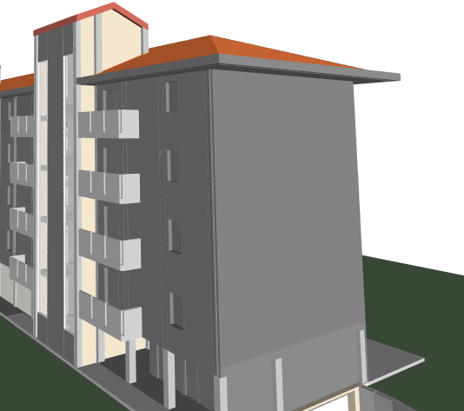

43) Details about the imported model dimensions and proportions

43.1) Does the model maintain its correct dimensions and proportions?

(i.e. it is not distorted nor scaled)

|  |  |
| --- | --- |
| ☐ Yes | |
| ☐ No → | 43.1.1) How do the dimensions change / how is the model distorted?  Give a description  43.1.2) Attach screenshots |
| ☐ The software does not have the necessary tools to check this information. | |

43.2) short comments to the previous question (43.1) (optional).

*Defined distance:16314 Measured distance: 16314*

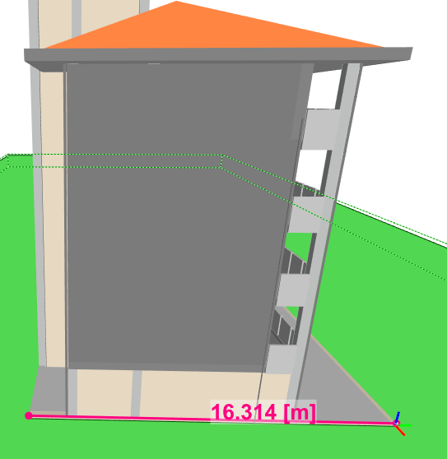

*Form 14/18*

Task 1 - 14/18

Following the test with the Savigliano.ifc model

**Semantics**

How are the semantics translated into the software's internal library / vocabulary?

44) Details about the classification

Is the IFC classification retained?

44.1) Is the eventual translation consistent with the IFC definitions?

(are the walls still walls, are the doors still doors and so on)

|  |  |
| --- | --- |
| ☐ Yes | |
| ☐ No → | 44.1.1) What changes / inconsistencies / errors / other issues were noted?  Give a description  44.1.2) Attach screenshots |
| ☐ The software does not have the necessary tools to check this information. | |

44.2) short comments to the previous question (44.1) (optional).

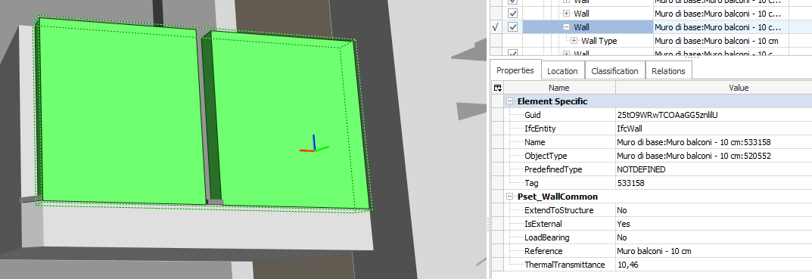

45) Details about the hierarchy

45.1) Are the hierarchical relationships consistent with the IFC hierarchy?

(are the class-subclass relationships maintained)

|  |  |
| --- | --- |
| ☐ Yes | |
| ☐ No → | 45.1.1) What changes / inconsistencies / errors / other issues were noted?  Give a description  45.1.2) Attach screenshots |
| ☐ The software does not have the necessary tools to check this information. | |

45.2) short comments to the previous question (45.1) (optional).

*Example of hierarchy:*

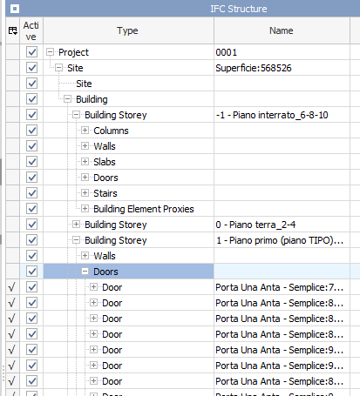

46) Details about the attributes

46.1) Are the attributes present in the IFC entities retained and consistent?

(can they all be read in connection to the related entities and have the correct meaning)

|  |  |
| --- | --- |
| ☐ Yes | |
| ☐ No → | 46.1.1) What changes / inconsistencies / errors / other issues were noted?  Give a description  46.1.2) Attach screenshots |
| ☐ The software does not have the necessary tools to check this information. | |

46.2) short comments to the previous question (46.1) (optional).

*Example of attributes:*

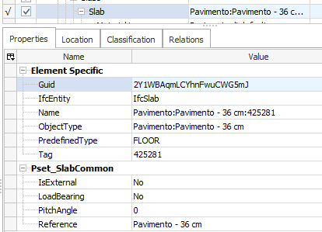

47) Details about the relationships

47.1) Are the relationships between the objects retained?

(intended as different from hierarchical relationships)

|  |  |
| --- | --- |
| ☐ Yes | |
| ☐ No → | 47.1.1) What changes / inconsistencies / errors / other issues were noted?  Give a description  47.1.2) Attach screenshots |
| ☐ The software does not have the necessary tools to check this information. | |

47.2) short comments to the previous question (47.1) (optional).

*Form 15/18*

Task 1 - 15/18

Following the test with the Savigliano.ifc model

**Geometry**

How are the geometries managed?

48) Details about the kind of geometries

48.1) Is geometry read correctly?

(solids are solids, surfaces are surfaces, objects are not grouped nor broken)

|  |  |
| --- | --- |
| ☐ Yes | |
| ☐ No → | 48.1.1) What changes / inconsistencies / errors / other issues were noted?  Give a description  481.2) Attach screenshots |
| ☐ The software does not have the necessary tools to check this information. | |

48.2) short comments to the previous question (48.1.1) (optional).

49) Details about the normals

49.1) Are normals not changed?

possibly, you can at least visually check this, through the way the objects are visualised (e.g. different colours for different faces directions)

|  |  |
| --- | --- |
| ☐ Yes | |
| ☐ No → | 49.1.1) What changes / inconsistencies / errors / other issues were noted?  Give a description  49.1.2) Attach screenshots |
| ☐ The software does not have the necessary tools to check this information. | |

49.2) short comments to the previous question (49.1) (optional).

*Visually, I think it is correct:*

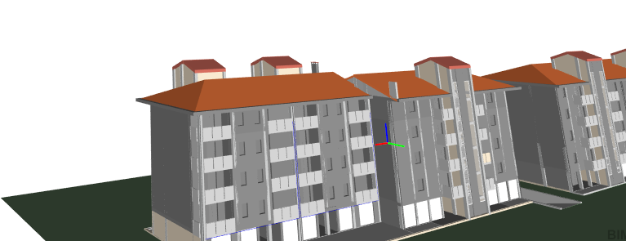

**Model management**

50) Visualisation 3D

50.1) Is it possible to view the model in 3D?

☐Yes

☐ No

50.2) short comments to the previous question (50.1) (optional).

51) Visualisation 2D

51.1) Is it possible to view the model in 2D?

☐ Yes

☐ No

51.2) short comments to the previous question (51.1) (optional).

52) Editing possibilities

52.1) Is it possible to edit the model (attributes, geometry, other)?

|  |  |
| --- | --- |
| ☐ No | |
| ☐ Yes→ | 52.1.1) What editing is possible (attributes, geometry, georeferencing, please add details)?  Give a description  52.1.2) Attach screenshots  52.1.3) Needed time to perform the edits  (approximately)  ⚠ NB: do not save the edits, as you will need to re-export the original data later on!  ☐ it’s almost immediate  ☐ less than a minute  ☐ 1-5 minutes  ☐ 5-20 minutes  ☐ 20 minutes - 1 hour  ☐ more than 1 hour  ☐ it crashes without completing the operation |

52.2) short comments to the previous question (52.1) (optional).

53) Query possibilities

53.1) Is it possible to query the model and the attributes?

|  |  |
| --- | --- |
| ☐ No | |
| ☐ Yes→ | 53.1.1) What kinds of query are possible?  Give a description  *There are general pre-defined ways to view the information, listed by structure, by types, by groups (system, zones or other) and by layers. For all these properties, location, classification and relations can be shown on the object level, see question 15.1.*  53.1.2) Attach screenshots  *List by systems:* |

53.2) short comments to the previous question (53.1) (optional).

54) Analysis possibilities

54.1) Is it possible to analyse the objects and the model?

|  |  |
| --- | --- |
| ☐ No | |
| ☐ Yes→ | 54.1.1) What analysis are possible? Do you know if the results are reliable?  Give a description  *Volume, area, edge, weight steel, counting and coordinates can be measured.*  *Do not know if it is reliable.*  54.1.2) Attach screenshots  *Volume:*    *Area:*    *Edge:*    *Concrete weight:*    *Coordinates:*    54.1.3) Needed time to perform the analysis  (approximately)  ☐ it’s almost immediate  ☐ less than a minute  ☐ 1-5 minutes  ☐ 5-20 minutes  ☐ 20 minutes - 1 hour  ☐ more than 1 hour  ☐ it crashes without completing the operation |

54.2) short comments to the previous question (54.1) (optional).

*Form 16/18*

Task 1 - 16/18

Following the test with the Savigliano.ifc model

**You arrived at the end of the Phase 1: “Import and manage the file in the software”**

Now choose:

☐ The software has also export abilities

☐ The software cannot export, therefore **skip the phase 2**

**Phase 2: EXPORT the data again to IFC and answer the following questions.**

(Only complete this section software tools having export functionality)

You should export the data to the **same IFC version of the provided data;** optionally, file(s) exported to **different IFC version(s)** can also be provided in addition, if multiple versions are offered by the software, and it is (/they are) **welcome.**

The needed customization is supposed to be the same reported for the test with Myran.ifc; otherwise, you can describe more details, and attach screenshots, in the following comment section.

55) How long does it take for the data to be exported to IFC?

(approximately)

☐ it’s almost immediate

☐ less than a minute

☐ 1-5 minutes

☐ 5-20 minutes

☐ 20 minutes - 1 hour

☐ more than 1 hour

☐ it crashes without completing the operation

55.1) Comment to the previous question (optional)

55.2) Attach screenshots (optional)

*Form 17/18*

Task 1 - 17/18

Following Section 4 – The Task

Test of specific geometries: **IFCgeometries.ifc**

In the next steps, you will test some specific kinds of geometries, using the IFCgeometries.ifc model

**Phase 1 – IMPORT FUNCTIONALITY.**

**Close and re-open the software again;**

**Import *IFCgeometries.ifc* into the software and answer the following questions.**

56) Import process

56.1) Does the software reports any error during the import process?

|  |  |
| --- | --- |
| ☐ No | |
| ☐ Yes → | 56.1.1) Which errors are reported by the software during the import process?  Give a description  56.1.2) Attach screenshots |
| ☐ The software does not have the necessary tools to check this information. | |
| ☐ Other___________________________________________________ | |

56.2) short comments to the previous question (56.1) (optional).

57) Initial performance time evaluation (More details in the web forms).

How long does it take, approximately, to:

|  |  |
| --- | --- |
| Import and visualise the model | ☐ it’s almost immediate  ☐ less than a minute  ☐ 1-5 minutes  ☐ 5-20 minutes  ☐ 20 minutes - 1 hour  ☐ more than 1 hour  ☐ it crashes without completing the operation  ☐ the software does not allow this |
| Zoom the model to see more detail | ☐ it’s almost immediate  ☐ less than a minute  ☐ 1-5 minutes  ☐ 5-20 minutes  ☐ 20 minutes - 1 hour  ☐ more than 1 hour  ☐ it crashes without completing the operation  ☐ the software does not allow this |
| Pan the model | ☐ it’s almost immediate  ☐ less than a minute  ☐ 1-5 minutes  ☐ 5-20 minutes  ☐ 20 minutes - 1 hour  ☐ more than 1 hour  ☐ it crashes without completing the operation  ☐ the software does not allow this |
| Rotate the model | ☐ it’s almost immediate  ☐ less than a minute  ☐ 1-5 minutes  ☐ 5-20 minutes  ☐ 20 minutes - 1 hour  ☐ more than 1 hour  ☐ it crashes without completing the operation  ☐ the software does not allow this |
| Query an object | ☐ it’s almost immediate  ☐ less than a minute  ☐ 1-5 minutes  ☐ 5-20 minutes  ☐ 20 minutes - 1 hour  ☐ more than 1 hour  ☐ it crashes without completing the operation  ☐ the software does not allow this |
| Inspect the objects linked to the queried one through a relationship | ☐ it’s almost immediate  ☐ less than a minute  ☐ 1-5 minutes  ☐ 5-20 minutes  ☐ 20 minutes - 1 hour  ☐ more than 1 hour  ☐ it crashes without completing the operation  ☐ the software does not allow this |

**Geometry**

How are the geometries managed?

58) Inspect the geometries in the software and answer the following questions.

58) Briefly describe every object you see. Please note that with ‘positive direction’ the direction towards the side of the reference grid where most of geometries are placed is intended.

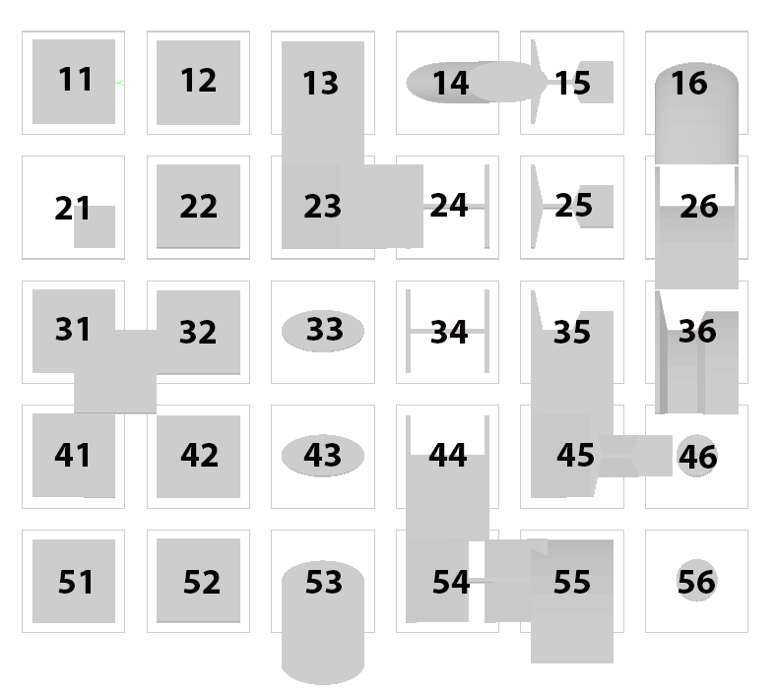

58.1) How do you visualize the geometry in place 11?

58.1.1) Is some object visible (besides the linear square representing the grid)?

|  |  |
| --- | --- |
| ☐ No, it’s missing |  |
| ☐ Yes → | 58.1.1.1) What is its position with relation to grid floor?    ☐ Below ☐ Below touching ☐ On ☐ Above touching ☐ Above  58.1.1.2) How do the curved surfaces look like?  ☐ Faceted ☐ Smooth ☐ no curved surfaces are present ☐other:______  58.1.1.3) What shape can you see?  ☐ a complete cube  ☐ a cube with subtraction in corner  ☐ a flattened shape  ☐ a cube with some missing faces  ☐ other____________________________ |
| ☐ Other___________________________________________________ | |

59.1) How do you visualize the geometry in place 12?

5(.1.1) Is some object visible (besides the linear square representing the grid)?

|  |  |
| --- | --- |
| ☐ No, it’s missing |  |
| ☐Yes → | 59.1.1.1) What is its position with relation to grid floor?    ☐ Below ☐ Below touching ☐ On ☐ Above touching ☐ Above  59.1.1.2) How do the curved surfaces look like?  ☐ Faceted ☐ Smooth ☐no curved surfaces are present ☐other:______  59.1.1.3) What shape can you see?  ☐ a complete cube  ☐ a cube with subtraction  ☐ a flattened shape  ☐ a cube with some missing faces  ☐ other____________________________ |
| ☐ Other___________________________________________________ | |

60.1) How do you visualize the geometry in place 13?

60.1.1) Is some object visible (besides the linear square representing the grid)?

|  |  |
| --- | --- |
| ☐ No, it’s missing |  |
| ☐Yes → | 60.1.1.1) What is its position with relation to grid floor?    ☐ Below ☐ Below touching ☐ On ☐ Above touching ☐ Above  60.1.1.2) How do the curved surfaces look like?  ☐ Faceted ☐ Smooth ☐ no curved surfaces are present ☐other:______  60.1.1.3) What shape can you see?  ☐ a complete cube  ☐ a cube with subtraction in corner  ☐ a flattened shape  ☐ a cube with some missing faces  ☐ other____________________________ |
| ☐ Other___________________________________________________ | |

61.1) How do you visualize the geometry in place 14?

61.1.1) Is some object visible (besides the linear square representing the grid)?

|  |  |
| --- | --- |
| ☐ No, it’s missing |  |
| ☐ Yes → | 61.1.1.1) What is its position with relation to grid floor?    ☐ Below ☐ Below touching ☐ On ☐ Above touching ☐ Above  61.1.1.2) How do the curved surfaces look like?  ☐ Faceted ☐ Smooth ☐ no curved surfaces are present ☐other:______  61.1.1.3) What shape can you see?  ☐ a cylinder with round base and oblique extrusion  ☐ a cylinder with elliptical base and oblique extrusion  ☐ an oblique prism  ☐ a cube  ☐ a flattened shape  ☐ other____________________________ |
| ☐ Other___________________________________________________ | |

62.1) How do you visualize the geometry in place 15?

62.1.1) Is some object visible (besides the linear square representing the grid)?

|  |  |
| --- | --- |
| ☐ No, it’s missing |  |
| ☐ Yes → | 62.1.1.1) What is its position with relation to grid floor?    ☐ Below ☐ Below touching ☐ On ☐ Above touching ☐ Above  62.1.1.2) How do the curved surfaces look like?  ☐ Faceted ☐ Smooth ☐ no curved surfaces are present ☐other:______  62.1.1.3) What shape can you see?  ☐ a beam: a 3D geometry derived by the extrusion of the base shape similar to the one in figure 1    ☐ a beam: a 3D geometry derived by the extrusion of the base shape similar to the one in figure 2    ☐ a beam: a 3D geometry derived by the extrusion of the base shape similar to the one in figure 3    ☐ a cube  ☐ a flattened shape  ☐ other____________________________ |
| ☐ Other___________________________________________________ | |

63.1) How do you visualize the geometry in place 16?

63.1.1) Is some object visible (besides the linear square representing the grid)?

|  |  |
| --- | --- |
| ☐ No, it’s missing |  |
| ☐ Yes → | 63.1.1.1) What is its position with relation to grid floor?    ☐ Below ☐ Below touching ☐ On ☐ Above touching ☐ Above  63.1.1.2) How do the curved surfaces look like?  ☐ Faceted ☐ Smooth ☐ no curved surfaces are present ☐other:______  63.1.1.3) What shape can you see?  ☐ a cylinder with elliptical base, extruded along a curved direction  ☐ a cube  ☐ a flattened shape  ☐ other____________________________ |
| ☐ Other___________________________________________________ | |

64.1) How do you visualize the geometry in place 21?

64.1.1) Is some object visible (besides the linear square representing the grid)?

|  |  |
| --- | --- |
| ☐ No, it’s missing |  |
| ☐ Yes → | 64.1.1.1) What is its position with relation to grid floor?    ☐ Below ☐ Below touching ☐ On ☐ Above touching ☐ Above  64.1.1.2) How do the curved surfaces look like?  ☐ Faceted ☐ Smooth ☐ no curved surfaces are present ☐other:______  64.1.1.3) What shape can you see?  ☐ a complete cube occupying the same size of earlier  ☐ a small cube in a corner  ☐ a flattened shape  ☐ a small cube in a corner with some missing faces  ☐ other____________________________ |
| ☐ Other___________________________________________________ | |

65.1) How do you visualize the geometry in place 22?

65.1.1) Is some object visible (besides the linear square representing the grid)?

|  |  |
| --- | --- |
| ☐ No, it’s missing |  |
| ☐ Yes → | 65.1.1.1) What is its position with relation to grid floor?    ☐ Below ☐ Below touching ☐ On ☐ Above touching ☐ Above  65.1.1.2) How do the curved surfaces look like?  ☐ Faceted ☐ Smooth ☐ no curved surfaces are present ☐other:______  65.1.1.3) What shape can you see?  ☐ a complete cube  ☐ a cube with subtraction in corner  ☐ a flattened shape  ☐ a cube with some missing faces  ☐ other____________________________ |
| ☐ Other___________________________________________________ | |

66.1) How do you visualize the geometry in place 23?

66.1.1) Is some object visible (besides the linear square representing the grid)?

|  |  |
| --- | --- |
| ☐ No, it’s missing |  |
| ☐ Yes → | 66.1.1.1) What is its position with relation to grid floor?    ☐ Below ☐ Below touching ☐ On ☐ Above touching ☐ Above  66.1.1.2) How do the curved surfaces look like?  ☐ Faceted ☐ Smooth ☐ no curved surfaces are present ☐other:______  66.1.1.3) What shape can you see?  ☐ a complete cube  ☐ an oblique prism  ☐ a flattened shape  ☐ other____________________________ |
| ☐ Other___________________________________________________ | |

67.1) How do you visualize the geometry in place 24?

67.1.1) Is some object visible (besides the linear square representing the grid)?

|  |  |
| --- | --- |
| ☐ No, it’s missing |  |
| ☐ Yes → | 67.1.1.1) What is its position with relation to grid floor?    ☐ Below ☐ Below touching ☐ On ☐ Above touching ☐ Above  67.1.1.2) How do the curved surfaces look like?  ☐ Faceted ☐ Smooth ☐ no curved surfaces are present ☐other:______  67.1.1.3) What shape can you see?  ☐ a beam: a 3D geometry derived by the extrusion of the base shape similar to the one in figure 1    ☐ a beam: a 3D geometry derived by the extrusion of the base shape similar to the one in figure 2    ☐ a cube  ☐ a flattened shape  ☐ other____________________________ |
| ☐ Other___________________________________________________ | |

68.1) How do you visualize the geometry in place 25?

68.1.1) Is some object visible (besides the linear square representing the grid)?

|  |  |
| --- | --- |
| ☐ No, it’s missing |  |
| ☐ Yes → | 68.1.1.1) What is its position with relation to grid floor?    ☐ Below ☐ Below touching ☐ On ☐ Above touching ☐ Above  68.1.1.2) How do the curved surfaces look like?  ☐ Faceted ☐ Smooth ☐ no curved surfaces are present ☐other:______  68.1.1.3) What shape can you see?  ☐ a beam: a 3D geometry derived by the extrusion of the base shape similar to the one in figure 1    ☐ a beam: a 3D geometry derived by the extrusion of the base shape similar to the one in figure 2    ☐ a beam: a 3D geometry derived by the extrusion of the base shape similar to the one in figure 3    ☐ a cube  ☐ a flattened shape  ☐ other____________________________ |
| ☐ Other___________________________________________________ | |

69.1) How do you visualize the geometry in place 26?

69.1.1) Is some object visible (besides the linear square representing the grid)?

|  |  |
| --- | --- |
| ☐ No, it’s missing |  |
| ☐ Yes → | 69.1.1.1) What is its position with relation to grid floor?    ☐ Below ☐ Below touching ☐ On ☐ Above touching ☐ Above  69.1.1.2) How do the curved surfaces look like?  ☐ Faceted ☐ Smooth ☐ no curved surfaces are present ☐other:______  69.1.1.3) What shape can you see?  ☐ a complete cube  ☐ a beam: a 3D geometry derived by the extrusion along a curved direction of the base shape similar to the one in figure 1    ☐ a beam: a 3D geometry derived by the extrusion along a curved direction of the base shape similar to the one in figure 2    ☐ a beam: a 3D geometry derived by the extrusion of the base shape similar to the one in figure 3  ☐ a flattened shape  ☐ other____________________________ |
| ☐ Other___________________________________________________ | |

70.1) How do you visualize the geometry in place 31?

71.1.1) Is some object visible (besides the linear square representing the grid)?

|  |  |
| --- | --- |
| ☐ No, it’s missing |  |
| ☐ Yes → | 71.1.1.1) What is its position with relation to grid floor?    ☐ Below ☐ Below touching ☐ On ☐ Above touching ☐ Above  71.1.1.2) How do the curved surfaces look like?  ☐ Faceted ☐ Smooth ☐ no curved surfaces are present ☐other:______  71.1.1.3) What shape can you see?  ☐ a complete cube  ☐ a shape deriving from the intersection of two cubes in a corner  ☐ a flattened shape  ☐ other____________________________ |
| ☐ Other___________________________________________________ | |

72.1) How do you visualize the geometry in place 32?

72.1.1) Is some object visible (besides the linear square representing the grid)?

|  |  |
| --- | --- |
| ☐ No, it’s missing |  |
| ☐ Yes → | 72.1.1.1) What is its position with relation to grid floor?    ☐ Below ☐ Below touching ☐ On ☐ Above touching ☐ Above  72.1.1.2) How do the curved surfaces look like?  ☐ Faceted ☐ Smooth ☐ no curved surfaces are present ☐other:______  72.1.1.3) What shape can you see?  ☐ a complete cube  ☐ a flattened shape  ☐ other____________________________ |
| ☐ Other___________________________________________________ | |

73.1) How do you visualize the geometry in place 33?

73.1.1) Is some object visible (besides the linear square representing the grid)?

|  |  |
| --- | --- |
| ☐ No, it’s missing |  |
| ☐ Yes → | 73.1.1.1) What is its position with relation to grid floor?    ☐ Below ☐ Below touching ☐ On ☐ Above touching ☐ Above  73.1.1.2) How do the curved surfaces look like?  ☐ Faceted ☐ Smooth ☐ no curved surfaces are present ☐other:______  73.1.1.3) What shape can you see?  ☐ a complete cube  ☐ a cylinder with round base  ☐ a cylinder with elliptical base  ☐ a prism  ☐ a flattened shape  ☐ other____________________________ |
| ☐ Other___________________________________________________ | |

74.1) How do you visualize the geometry in place 34?

74.1.1) Is some object visible (besides the linear square representing the grid)?

|  |  |
| --- | --- |
| ☐ No, it’s missing |  |
| ☐ Yes → | 74.1.1.1) What is its position with relation to grid floor?    ☐ Below ☐ Below touching ☐ On ☐ Above touching ☐ Above  74.1.1.2) How do the curved surfaces look like?  ☐ Faceted ☐ Smooth ☐ no curved surfaces are present ☐other:______  74.1.1.3) What shape can you see?  ☐ a beam: a 3D geometry derived by the extrusion of the base shape similar to the one in figure 1    ☐ a beam: a 3D geometry derived by the extrusion of the base shape similar to the one in figure 2    ☐ a beam: a 3D geometry derived by the extrusion of the base shape similar to the one in figure 3  ☐ a cube  ☐ a flattened shape  ☐ other____________________________ |
| ☐ Other___________________________________________________ | |

75.1) How do you visualize the geometry in place 35?

75.1.1) Is some object visible (besides the linear square representing the grid)?

|  |  |
| --- | --- |
| ☐ No, it’s missing |  |
| ☐ Yes → | 75.1.1.1) What is its position with relation to grid floor?    ☐ Below ☐ Below touching ☐ On ☐ Above touching ☐ Above  75.1.1.2) How do the curved surfaces look like?  ☐ Faceted ☐ Smooth ☐ no curved surfaces are present ☐other:______  75.1.1.3) What shape can you see?  ☐ a complete cube  ☐ a beam: a 3D geometry derived by the oblique extrusion of the base shape similar to the one in figure 1    ☐ a beam: a 3D geometry derived by the oblique extrusion of the base shape similar to the one in figure 2    ☐ a beam: a 3D geometry derived by the oblique extrusion of the base shape similar to the one in figure 3    ☐ a flattened shape  ☐ other____________________________ |
| ☐ Other___________________________________________________ | |

76.1) How do you visualize the geometry in place 36?

76.1.1) Is some object visible (besides the linear square representing the grid)?

|  |  |
| --- | --- |
| ☐ No, it’s missing |  |
| ☐ Yes → | 76.1.1.1) What is its position with relation to grid floor?    ☐ Below ☐ Below touching ☐ On ☐ Above touching ☐ Above  76.1.1.2) How do the curved surfaces look like?  ☐ Faceted ☐ Smooth ☐ no curved surfaces are present ☐other:______  76.1.1.3) What shape can you see?  ☐ a complete cube  ☐ a beam: a 3D geometry derived by the extrusion along a curved line of the base shape similar to the one in figure 1    ☐ a beam: a 3D geometry derived by the extrusion along a curved line of the base shape similar to the one in figure 2    ☐ a beam: a 3D geometry derived by the extrusion along a curved line of the base shape similar to the one in figure 3    ☐ a cube  ☐ a flattened shape ☐ other____________________________ |
| ☐ Other___________________________________________________ | |

77.1) How do you visualize the geometry in place 41?

77.1.1) Is some object visible (besides the linear square representing the grid)?

|  |  |
| --- | --- |
| ☐ No, it’s missing |  |
| ☐ Yes → | 77.1.1.1) What is its position with relation to grid floor?    ☐ Below ☐ Below touching ☐ On ☐ Above touching ☐ Above  77.1.1.2) How do the curved surfaces look like?  ☐ Faceted ☐ Smooth ☐ no curved surfaces are present ☐other:______  77.1.1.3) What shape can you see?  ☐ a complete cube  ☐ a triangular prism  ☐ a flattened shape  ☐ other____________________________ |
| ☐ Other___________________________________________________ | |

78.1) How do you visualize the geometry in place 42?

78.1.1) Is some object visible (besides the linear square representing the grid)?

|  |  |
| --- | --- |
| ☐No, it’s missing |  |
| ☐ Yes → | 78.1.1.1) What is its position with relation to grid floor?    ☐ Below ☐ Below touching ☐ On ☐ Above touching ☐ Above  78.1.1.2) How do the curved surfaces look like?  ☐ Faceted ☐ Smooth ☐ no curved surfaces are present ☐other:______  78.1.1.3) What shape can you see?  ☐ a complete cube  ☐ an oblique prism  ☐ a cube  ☐ a flattened shape  ☐ other____________________________ |
| ☐ Other___________________________________________________ | |

79.1) How do you visualize the geometry in place 43?

79.1.1) Is some object visible (besides the linear square representing the grid)?

|  |  |
| --- | --- |
| ☐ No, it’s missing |  |
| ☐ Yes → | 79.1.1.1) What is its position with relation to grid floor?    ☐ Below ☐ Below touching ☐ On ☐ Above touching ☐ Above  79.1.1.2) How do the curved surfaces look like?  ☐ Faceted ☐ Smooth ☐ no curved surfaces are present ☐other:______  79.1.1.3) What shape can you see?  ☐ a complete cube  ☐ a cylinder with round base  ☐ a cylinder with elliptical base  ☐ a prism  ☐ a flattened shape  ☐ other____________________________ |
| ☐ Other___________________________________________________ | |

80.1) How do you visualize the geometry in place 44?

80.1.1) Is some object visible (besides the linear square representing the grid)?

|  |  |
| --- | --- |
| ☐ No, it’s missing |  |
| ☐ Yes → | 80.1.1.1) What is its position with relation to grid floor?    ☐ Below ☐ Below touching ☐ On ☐ Above touching ☐ Above  80.1.1.2) How do the curved surfaces look like?  ☐ Faceted ☐ Smooth ☐ no curved surfaces are present ☐other:______  80.1.1.3) What shape can you see?  ☐ a complete cube  ☐ a beam: a 3D geometry derived by the oblique extrusion of the base shape similar to the one in figure 1    ☐ a beam: a 3D geometry derived by the oblique extrusion of the base shape similar to the one in figure 2    ☐ a flattened shape  ☐ other____________________________ |
| ☐ Other___________________________________________________ | |

81.1) How do you visualize the geometry in place 45?

81.1.1) Is some object visible (besides the linear square representing the grid)?

|  |  |
| --- | --- |
| ☐ No, it’s missing |  |
| ☐ Yes → | 81.1.1.1) What is its position with relation to grid floor?    ☐ Below ☐ Below touching ☐ On ☐ Above touching ☐ Above  81.1.1.2) How do the curved surfaces look like?  ☐ Faceted ☐ Smooth ☐ no curved surfaces are present ☐other:______  81.1.1.3) What shape can you see?  ☐ a complete cube  ☐ a beam: a 3D geometry derived by the extrusion of the base shape similar to the one in figure 1    ☐ a beam: a 3D geometry derived by the extrusion of the base shape similar to the one in figure 2    ☐ a beam: a 3D geometry derived by the extrusion of the base shape similar to the one in figure 3    ☐ a flattened shape  ☐ other____________________________ |
| ☐ Other___________________________________________________ | |

82.1) How do you visualize the geometry in place 46?

82.1.1) Is some object visible (besides the linear square representing the grid)?

|  |  |
| --- | --- |
| ☐ No, it’s missing |  |
| ☐ Yes → | 82.1.1.1) What is its position with relation to grid floor?    ☐ Below ☐ Below touching ☐ On ☐ Above touching ☐ Above  82.1.1.2) How do the curved surfaces look like?  ☐ Faceted ☐ Smooth ☐ no curved surfaces are present ☐other:______  82.1.1.3) What shape can you see?  ☐ a complete cube  ☐ a cylinder with small round base  ☐ a cylinder with elliptical base  ☐ a prism  ☐ a flattened shape  ☐ other____________________________ |
| ☐ Other___________________________________________________ | |

83.1) How do you visualize the geometry in place 51?

83.1.1) Is some object visible (besides the linear square representing the grid)?

|  |  |
| --- | --- |
| ☐ No, it’s missing |  |
| ☐ Yes → | 83.1.1.1) What is its position with relation to grid floor?    ☐ Below ☐ Below touching ☐ On ☐ Above touching ☐ Above  83.1.1.2) How do the curved surfaces look like?  ☐ Faceted ☐ Smooth ☐ no curved surfaces are present ☐other:______  83.1.1.3) What shape can you see?  ☐ a complete cube  ☐ …  ☐ a flattened shape  ☐ other____________________________ |
| ☐ Other___________________________________________________ | |

84.1) How do you visualize the geometry in place 52?

84.1.1) Is some object visible (besides the linear square representing the grid)?

|  |  |
| --- | --- |
| ☐ No, it’s missing |  |
| ☐ Yes → | 84.1.1.1) What is its position with relation to grid floor?    ☐ Below ☐ Below touching ☐ On ☐ Above touching ☐ Above  84.1.1.2) How do the curved surfaces look like?  ☐ Faceted ☐ Smooth ☐ no curved surfaces are present ☐other:______  84.1.1.3) What shape can you see?  ☐ a complete cube  ☐ a box twice as tall as most of other cubes  ☐ a flattened shape  ☐ other____________________________ |
| ☐ Other___________________________________________________ | |

85.1) How do you visualize the geometry in place 53?

85.1.1) Is some object visible (besides the linear square representing the grid)?

|  |  |
| --- | --- |
| ☐ No, it’s missing |  |
| ☐ Yes → | 85.1.1.1) What is its position with relation to grid floor?    ☐ Below ☐ Below touching ☐ On ☐ Above touching ☐ Above  85.1.1.2) How do the curved surfaces look like?  ☐ Faceted ☐ Smooth ☐ no curved surfaces are present ☐other:______  85.1.1.3) What shape can you see?  ☐ a complete cube  ☐ a cylinder with round base and oblique extrusion  ☐ a cylinder with elliptical base and oblique extrusion  ☐ a cylinder with elliptical base  ☐ an oblique prism  ☐ a flattened shape  ☐ other____________________________ |
| ☐ Other___________________________________________________ | |

86.1) How do you visualize the geometry in place 54?

86.1.1) Is some object visible (besides the linear square representing the grid)?

|  |  |
| --- | --- |
| ☐ No, it’s missing |  |
| ☐ Yes → | 86.1.1.1) What is its position with relation to grid floor?    ☐ Below ☐ Below touching ☐ On ☐ Above touching ☐ Above  86.1.1.2) How do the curved surfaces look like?  ☐ Faceted ☐ Smooth ☐ no curved surfaces are present ☐other:______  86.1.1.3) What shape can you see?  ☐ a complete cube  ☐ a beam: a 3D geometry derived by the oblique extrusion of the base shape similar to the one in figure 1    ☐ a beam: a 3D geometry derived by the extrusion of the base shape similar to the one in figure 2    ☐ a flattened shape  ☐ other____________________________ |
| ☐ Other___________________________________________________ | |

87.1) How do you visualize the geometry in place 55?

87.1.1) Is some object visible (besides the linear square representing the grid)?

|  |  |
| --- | --- |
| ☐ No, it’s missing |  |
| ☐ Yes → | 87.1.1.1) What is its position with relation to grid floor?    ☐ Below ☐ Below touching ☐ On ☐ Above touching ☐ Above  87.1.1.2) How do the curved surfaces look like?  ☐ Faceted ☐ Smooth ☐ no curved surfaces are present ☐other:______  87.1.1.3) What shape can you see?  ☐ a complete cube  ☐ a shape deriving from the extrusion of a square towards a curved line  ☐ a flattened shape  ☐ other____________________________ |
| ☐ Other___________________________________________________ | |

88.1) How do you visualize the geometry in place 56?

88.1.1) Is some object visible (besides the linear square representing the grid)?

|  |  |
| --- | --- |
| ☐ No, it’s missing |  |
| ☐ Yes → | 88.1.1.1) What is its position with relation to grid floor?    ☐ Below ☐ Below touching ☐ On ☐ Above touching ☐ Above  88.1.1.2) How do the curved surfaces look like?  ☐ Faceted ☐ Smooth ☐ no curved surfaces are present ☐other:______  88.1.1.3) What shape can you see?  ☐ a complete cube  ☐ a cylinder with small round base  ☐ a cylinder with elliptical base  ☐ a prism  ☐ a flattened shape  ☐ other____________________________ |
| ☐ Other___________________________________________________ | |

61) Cylinder

61.1) Do the two cylinders in the corner (positions 46 and 56) have the same length?

|  |  |
| --- | --- |
| ☐ Yes | |
| ☐ No → | 61.1.1) How do they differ?  Give a description  61.1.2) Attach screenshots |
| ☐ The software does not have the necessary tools to check this information. | |
| ☐ Other | |

61.2) short comments to the previous question (61.1) (optional).

62) H-beams

62.1) Do the two vertical H beams (positions 24 and 34) have the same length?

|  |  |
| --- | --- |
| ☐ Yes | |
| ☐ No → | 62.1.1) How do they differ?  Give a description  62.1.2) Attach screenshots |
| ☐ The software does not have the necessary tools to check this information. | |
| ☐ Other | |

62.2) short comments to the previous question (62.1) (optional).

63) H-beams-2

63.1) Do all the H beams (positions 24,26,34,44,54) have round corners towards the centre?

|  |  |
| --- | --- |
| ☐ Yes | |
| ☐ No → | 63.1.1) How do they differ?  Give a description  63.1.2) Attach screenshots |
| ☐ The software does not have the necessary tools to check this information. | |
| ☐ Other | |

63.2) short comments to the previous question (63.1) (optional).

*64*) Details about the normals

64.1) Are normals not changed?

possibly, you can at least visually check this, through the way the objects are visualised (e.g. different colours for different faces directions)

|  |  |
| --- | --- |
| ☐ Yes | |
| ☐ No → | 64.1.1) What changes / inconsistencies / errors / other issues were noted?  Give a description  64.1.2) Attach screenshots |
| ☐ The software does not have the necessary tools to check this information. | |

64.2) short comments to the previous question (64.1) (optional).

**You arrived at the end of the Phase 1: “Import and manage the file in the software”**

Now choose:

☐ The software has also export abilities

☐ The software cannot export, therefore **skip the phase 2**

**Phase 2: EXPORT the data again to IFC and answer the following questions.**

(Only complete this section software tools having export functionality)

You should export the data to the **same IFC version of the provided data;** optionally, file(s) exported to **different IFC version(s)** can also be provided in addition, if multiple versions are offered by the software, and it is (/they are) **welcome.**

65) How long does it take for the data to be exported to IFC?

(approximately)

☐ it’s almost immediate

☐ less than a minute

☐ 1-5 minutes

☐ 5-20 minutes

☐ 20 minutes - 1 hour

☐ more than 1 hour

☐ it crashes without completing the operation

66) Any comments or observations regarding export (errors, needed customisations…)?

*Form 18/18*

Task 1 - 18/18

Following Section 4 – The Task

Test of specific geometries: **IFCgeometries_IFC4.ifc**

In the next steps, you will test some specific kinds of geometries, using the analytics.ifc model

**Phase 1 – IMPORT FUNCTIONALITY.**

**Close and re-open the software again;**

**Import** ***analytics.ifc* into the software and answer the following questions.**

68) Import process

68.1) Does the software reports any error during the import process?

|  |  |
| --- | --- |
| ☐ No | |
| ☐ Yes → | 68.1.1) Which errors are reported by the software during the import process?  Give a description  68.1.2) Attach screenshots |
| ☐ The software does not have the necessary tools to check this information. | |
| ☐ Other___________________________________________________ | |

68.2) short comments to the previous question (68.1) (optional).

69) Initial performance time evaluation (More details in the web forms).

How long does it take, approximately, to:

|  |  |
| --- | --- |
| Import and visualise the model | ☐ it’s almost immediate  ☐ less than a minute  ☐ 1-5 minutes  ☐ 5-20 minutes  ☐ 20 minutes - 1 hour  ☐ more than 1 hour  ☐ it crashes without completing the operation  ☐ the software does not allow this |
| Zoom the model to see more detail | ☐ it’s almost immediate  ☐ less than a minute  ☐ 1-5 minutes  ☐ 5-20 minutes  ☐ 20 minutes - 1 hour  ☐ more than 1 hour  ☐ it crashes without completing the operation  ☐ the software does not allow this |
| Pan the model | ☐ it’s almost immediate  ☐ less than a minute  ☐ 1-5 minutes  ☐ 5-20 minutes  ☐ 20 minutes - 1 hour  ☐ more than 1 hour  ☐ it crashes without completing the operation  ☐ the software does not allow this |
| Rotate the model | ☐ it’s almost immediate  ☐ less than a minute  ☐ 1-5 minutes  ☐ 5-20 minutes  ☐ 20 minutes - 1 hour  ☐ more than 1 hour  ☐ it crashes without completing the operation  ☐ the software does not allow this |
| Query an object | ☐ it’s almost immediate  ☐ less than a minute  ☐ 1-5 minutes  ☐ 5-20 minutes  ☐ 20 minutes - 1 hour  ☐ more than 1 hour  ☐ it crashes without completing the operation  ☐ the software does not allow this |
| Inspect the objects linked to the queried one through a relationship | ☐ it’s almost immediate  ☐ less than a minute  ☐ 1-5 minutes  ☐ 5-20 minutes  ☐ 20 minutes - 1 hour  ☐ more than 1 hour  ☐ it crashes without completing the operation  ☐ the software does not allow this |

**Geometry**

How are the geometries managed?

Inspect the geometries in the software and answer the following questions.

70)

[This part of the form is missing, but, as a reference, you can consider that it is very similar to question 58, but related to the file IFC4geometries]

73.1) Do the two cylinders in the corner (positions 46 and 56) have the same length?

|  |  |
| --- | --- |
| ☐ Yes | |
| ☐ No → | 73.1.1) How do they differ?  Give a description  73.1.2) Attach screenshots |
| ☐ The software does not have the necessary tools to check this information. | |
| ☐ Other | |

73.2) short comments to the previous question (73.1) (optional).

74) H-beams

74.1) Do the two vertical H beams (positions 24 and 34) have the same length?

|  |  |
| --- | --- |
| ☐ Yes | |
| ☐ No → | 74.1.1) How do they differ?  Give a description  741.2) Attach screenshots |
| ☐ The software does not have the necessary tools to check this information. | |
| ☐ Other | |

74.2) short comments to the previous question (74.1) (optional).

76) Details about the normals

76.1) Are normals not changed?

possibly, you can at least visually check this, through the way the objects are visualised (e.g. different colours for different faces directions)

|  |  |
| --- | --- |
| ☐ Yes | |
| ☐ No → | 76.1.1) What changes / inconsistencies / errors / other issues were noted?  Give a description  76.1.2) Attach screenshots |
| ☐ The software does not have the necessary tools to check this information. | |

76.2) short comments to the previous question (76.1) (optional).

**You arrived at the end of the Phase 1: “Import and manage the file in the software”**

Now choose:

☐ The software has also export abilities

☐ The software cannot export, therefore **skip the phase 2**

**Phase 2: EXPORT the data again to IFC and answer the following questions.**

(Only complete this section software tools having export functionality)

You should export the data to the **same IFC version of the provided data;** optionally, file(s) exported to **different IFC version(s)** can also be provided in addition, if multiple versions are offered by the software, and it is (/they are) **welcome.**

77) How long does it take for the data to be exported to IFC?

(approximately)

☐ it’s almost immediate

☐ less than a minute

☐ 1-5 minutes

☐ 5-20 minutes

☐ 20 minutes - 1 hour

☐ more than 1 hour

☐ it crashes without completing the operation

**Section 5 - Finalisation**

## 78) Would you like to share any other comments or observations? (They are all welcome).

## 79) Attach other screenshots or files that you consider useful. (optional).

In addition, you can attach this filled form in word format. (optional, do it only if you think that some information was not given effectively through the web form).

☐ **I hereby declare that all the information provided and the answers given are true, correct and detailed as much as I could provide (mandatory). Moreover, I give my consent to use these results for the benchmark activities and analysis as described in the website (**[**https://3d.bk.tudelft.nl/projects/geobim-benchmark/**](https://3d.bk.tudelft.nl/projects/geobim-benchmark/)**) and connected research (mandatory).**

☐ I give my consent to publish these results (anonymously) within the benchmark outcomes, as open data (optional but welcome).

☐ I declare that, in the delivered results, no personal information is present that will allow me to be identified (except for personal and contact details).

☐ I agree my name, affiliation, nationality and photo/logo to be added in the benchmark website, in the section listing who participated to the scientific initiative. My personal details will not be linked to the test results I have provided.

☐ I agree to my e-mail address being added to the mailing list of this project in order to follow the project progress and connected activities information.

80) Use this link to upload **the files in the used software (used native format)**

If the software allows to save the project in its native format, it is **required**.

The files must be **named** like the following:

*T1_Name of the used IFC file_Name of the used software_Your name (initial+surname).native format*

*e.g. T1_Myran_Revit_FNoardo.rvt*

81) Use this link to upload **the exported IFC files**

In the case the software has export functionalities, it is **required**

If you exported the file in various IFC versions, please upload them all here.

The files must be named like the following:

*T1_Name of the used IFC file_Name of the used software_IFC version_Your name (initial+surname).ifc*

*e.g. T1_Myran_Revit_IFC2x3_FNoardo.ifc*

Thank you very much for your contribution!

 Please remember to deliver:

* The file imported in the tested software **(native) format**
* This answered results template (by submitting this **filled online form**)
* The **exported IFC** file (only if a software with export ability was tested

1. **Please, give them an understandable title, or put them in a word/pdf file with titles or captions** [This refers to all the cases where screenshots or documents are asked to be attached]
2. Please, give them an understandable title; in this case, a word/pdf file containing the tutorial with screenshots and their captions can be the most effective solution.
3. **Please, give them an understandable title, or put them in a word/pdf file with titles or captions** [This refers to all the cases where screenshots or documents are asked to be attached]